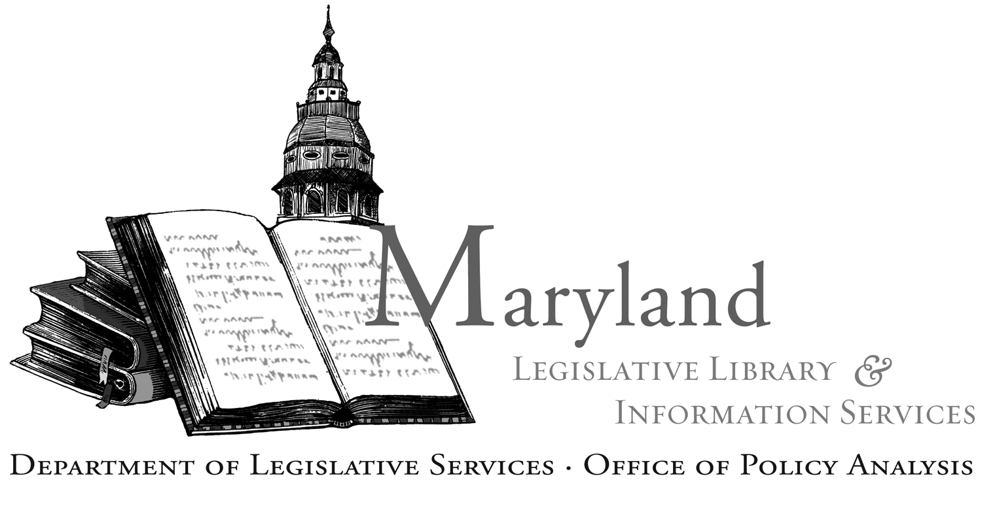

Committee Meetings and Hearing Schedule

Request for Publication

Library and Information Services
Department of Legislative Services
90 State Circle
Annapolis, MD 21401-1991
410-946/301-970-5400

Tow Committee
Name of Committee/Subcommittee/Work Group/Commission/Task Force

Jason Little, Maryland Insurance Administration
Chair
N/A
(If a Subcommittee or Work Group, Indicate Name of Full Committee)

Meeting Date:

Wednesday | 10/28/2026 | 9am
DAY OF WEEK | MONTH, DAY, YEAR | TIME
(Please enter text in upper case)

Meeting Location:

Virtual:
https://meet.google.com/exe-ctao-zfc
Room Number
Or open Meet and enter this code:
exe-ctao-zfc
Dial in (audio only):
(US) +1 252-656-5199 PIN: 288 927 675#
Street Address
City and State (no zip code)

Subject of Meeting: | Meeting #2: Establish approved rates for light duty towing
Subject of Meeting: | Tow complaint adjudication
Subject of Meeting: | Establish a process to suspend or remove a tow company
Subject of Meeting: | Other matters
For Further Information, Contact: |  | F/Sgt. John Pietanza
 |  | Name
 |  | Maryland State Police
 |  | Agency

Telephone/email: | 443-936-5958 john.pietanza@maryland.gov

NOTE: Submit meeting notices to Liz Mehl, Library and Information Services at elizabeth.mehl@mlis.state.md.us or to hearing.schedule@mlis.state.md.us

